- Vehicles
Write a program that models 2 vehicles (Car and Truck) and will be able to simulate driving and refueling them. Car and truck both have fuel quantity, fuel consumption in liters per km and can be driven given distance and refueled with given liters. But in the summer both vehicles use air conditioner and their fuel consumption per km is increased by 0.9 liters for the car and with 1.6 liters for the truck. Also the truck has a tiny hole in his tank and when it gets refueled it gets only 95% of given fuel. The car has no problems when refueling and adds all given fuel to its tank. If a vehicle cannot travel the given distance its fuel does not change.
Input
On the first line - information about the car in format {Car {fuel quantity} {liters per km}}
On the second line – info about the truck in format {Truck {fuel quantity} {liters per km}}
On the third line - number of commands N that will be given on the next N lines
On the next N lines – commands in format
Drive Car {distance}
Drive Truck {distance}
Refuel Car {liters}
Refuel Truck {liters}
Output
After each Drive command print whether the Car/Truck was able to travel the given distance in the formats below. If it’s successful:
Car/Truck travelled {distance} km
Or if it is not:
Car/Truck needs refueling
Finally print the remaining fuel for both car and truck rounded to 2 digits after the floating point in format:
Car: {liters}
Truck: {liters}
Examples
Input | Output
Car 15 0.3  Truck 100 0.9  4  Drive Car 9  Drive Car 30  Refuel Car 50  Drive Truck 10 | Car travelled 9 km  Car needs refueling  Truck travelled 10 km  Car: 54.20  Truck: 75.00
Car 30.4 0.4  Truck 99.34 0.9  5  Drive Car 500  Drive Car 13.5  Refuel Truck 10.300  Drive Truck 56.2  Refuel Car 100.2 | Car needs refueling  Car travelled 13.5 km  Truck needs refueling  Car: 113.05  Truck: 109.13

- Vehicles Extension
Use your solution of the previous task for starting point and add more functionality. Add new vehicle – Bus. Now every vehicle has tank capacity and fuel quantity cannot fall below 0 (If fuel quantity become less than 0 print on the console “Fuel must be a positive number”).
The car and the bus cannot be filled up with more fuel than their tank capacity. If you try to put more fuel in the tank than the available space, print on the console “Cannot fit fuel in tank” and do not add any fuel in vehicles tank.
Add new command for the bus. The bus can drive with or without people. If the bus is driving with people, the air-conditioner is turned on and its fuel consumption per kilometer is increased with 1.4 liters. If there are no people in the bus when driving the air-conditioner is turned off and does not increase the fuel consumption.
Input
On the first three lines you will receive information about the vehicles in format:
Vehicle {initial fuel quantity} {liters per km} {tank capacity}
On fourth line - number of commands N that will be given on the next N lines
On the next N lines – commands in format
Drive Car {distance}
Drive Truck {distance}
Drive Bus {distance}
DriveEmpty Bus {distance}
Refuel Car {liters}
Refuel Truck {liters}
Refuel Bus {liters}
Output
After each Drive command print whether the Car/Truck was able to travel given distance in format if it’s successful:
Car/Truck/Bus travelled {distance} km
Or if it is not:
Car/Truck/Bus needs refueling
If given fuel is ≤ 0 print “Fuel must be a positive number”.
If given fuel cannot fit in car or bus tank print “Cannot fit in tank”
Finally print the remaining fuel for both car and truck rounded 2 digits after floating point in format:
Car: {liters}
Truck: {liters}
Bus: {liters}

Example
Input | Output
Car 30 0.04 70  Truck 100 0.5 300  Bus 40 0.3 150  8  Refuel Car -10  Refuel Truck 0  Refuel Car 10  Refuel Car 300  Drive Bus 10  Refuel Bus 1000  DriveEmpty Bus 100  Refuel Truck 1000 | Fuel must be a positive number  Fuel must be a positive number  Cannot fit fuel in tank  Bus travelled 10 km  Cannot fit fuel in tank  Bus needs refueling  Car: 40.00  Truck: 1050.00  Bus: 23.00

- Wild farm
Your task is to create a class hierarchy like in the picture below. All the classes except Vegetable, Meat, Mouse, Tiger, Cat & Zebra should be abstract. Override method ToString().
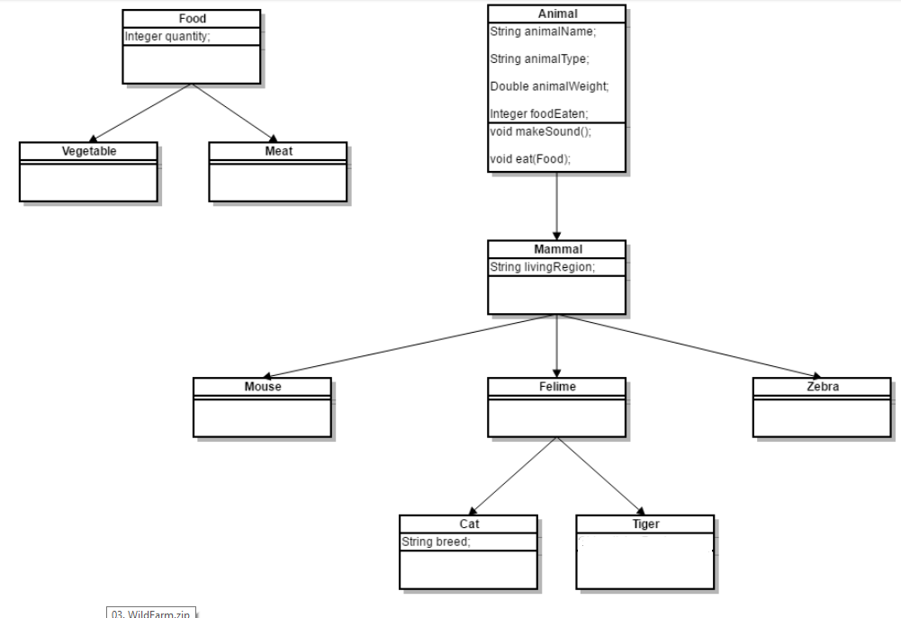
Input should be read from the console. Every odd line will contain information about the Animal in following format:
{AnimalType} {AnimalName} {AnimalWeight} {AnimalLivingRegion} [{CatBreed} = Only if its cat]
On the even lines you will receive information about the food that you should give to the Animal. The line will consist of FoodType and quantity separated by a whitespace.
{FoodType} {Quantiy}
You should build the logic to determine if the animal is going to eat the provided food. The Mouse and Zebra should check if the food is a Vegetable. If it is they will eat it - otherwise you should print a message in the format:
{AnimalType in plural} are not eating that type of food!

Cats eat any kind of food, but Tigers accept only Meat. If Vegetable is provided to a Tiger message like the one above should be printed on the console.

Override ToString() method to print the information about the animal in format:

{AnimalType}[{AnimalName}, {CatBreed}, {AnimalWeight}, {AnimalLivingRegion}, {FoodEaten}]
After you read information about the Animal and Food then invoke the MakeSound() method of the current animal and then feed it. At the end print the whole object and proceed reading information about the next animal/food. The input will continue until you receive “End” for animal information.
Sounds produced by the animals:
Mouse – “SQUEEEAAAK!”
Zebra – “Zs”
Cat – “Meowwww”
Tiger – “ROAAR!!!”
Input
You will receive lines on the Console until the command “End” is received. On every odd line you will be provided with information about an animal. On every even line you will receive the food which is given to the animal.
Output
For each animal you have read, print two lines on the Console:
On the first line: the sound produced by the animal
On the second line: all the information about the animal in the format described above
Example
Input | Output
Cat Gray 1.1 Home Persian  Vegetable 4  End | Meowwww  Cat[Gray, Persian, 1.1, Home, 4]
Tiger Typcho 167.7 Asia  Vegetable 1  End | ROAAR!!!  Tigers are not eating that type of food!  Tiger[Typcho, 167.7, Asia, 0]
Zebra Doncho 500 Africa  Vegetable 150  End | Zs  Zebra[Doncho, 500, Africa, 150]
Mouse Jerry 0.5 Anywhere  Vegetable 0  End | SQUEEEAAAK!  Mouse[Jerry, 0.5, Anywhere, 0]

